Java Full Stack
What is Java Full Stack?
Java Full Stack refers to a developer who can work on both the front-end (client side) and back-end (server side) of a web application using Java and related technologies.
Java Full Stack Development is the practice of building both the front-end and back-end of a web application using Java-based technologies for the back-end.
Front-End:
- Front-end is the part of a website or web application that users see and interact with directly. It’s also called the client-side.
Backend:
- The Back-End (also called server-side) is the part of a web application that works behind the scenes — it handles business logic, processes user requests, interacts with the database, and sends data to the front-end.
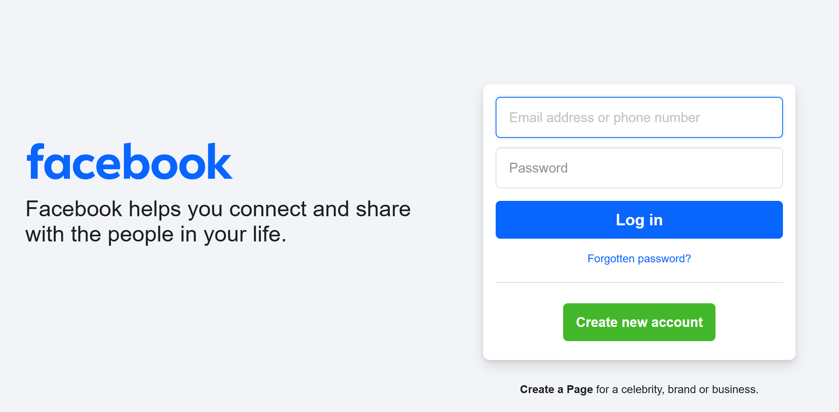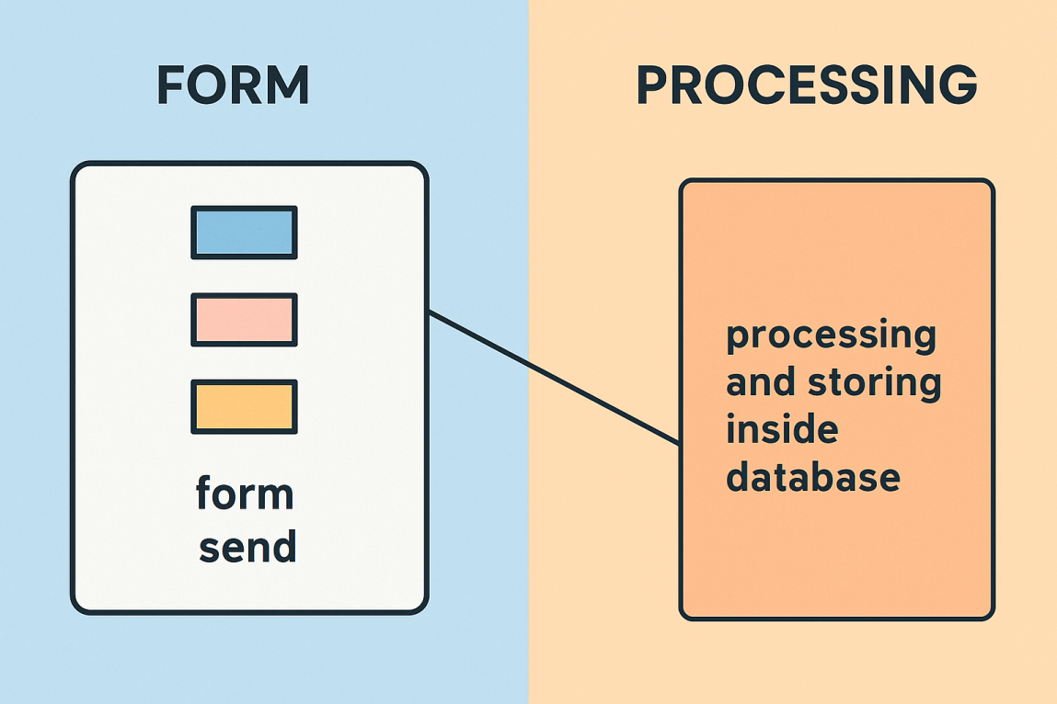
Website vs Web Application (WebApp)
Website:
A website is a collection of static or dynamic pages that present content to users. It's mainly informational.
- Mostly read-only content
- Less user interaction
- Examples: blogs, company info sites

Web Application (WebApp):
A web application is a dynamic, interactive system where users can log in, perform actions, and receive output.
- Users can interact with the system
- Has login/signup, forms, dashboards, etc.
- Uses a backend + database
- Data changes based on user input
Example:
- Amazon, Flipkart
- Gmail, Facebook
- Admin dashboard, Student portal

Why Learn Java Full Stack?
1. High Demand in Job Market
- Companies prefer developers who can handle both front-end and back-end.
- Java Full Stack developers are in high demand for enterprise, fintech, e-commerce, and startup jobs.
2. Build Complete Projects
- You can independently create full web apps: login systems, dashboards, portals, etc.
- No need to depend on separate front-end or back-end teams.
3. Java is Trusted by Big Companies
- Java is stable, secure, and widely used by companies like Amazon, Microsoft, Google, TCS, Infosys, etc.
- It’s backed by a strong ecosystem like Spring, Spring Boot, and Hibernate.
4. Better Salary Opportunities
- Full Stack Developers usually earn more than pure front-end or back-end developers.
5. Strong Community and Support
- Java has vast documentation, a large community, and a wide range of tools for faster development.
6. Java’s Speed and Performance
- Java offers high performance.
- It's ideal for building fast, scalable, and real-time applications.

Client-Server Architecture
- So, we are learning Java Full Stack to become capable of creating real-world web applications.
- But have you ever wondered — how exactly are web applications developed in IT companies?
- What happens behind the scenes when you open a website or click a button on an app?
- To understand that, we need to look at the Client-Server Architecture, which forms the backbone of how modern web applications work.
- Let’s dive into the big picture and see how front-end, back-end, and databases communicate in a real project setup.
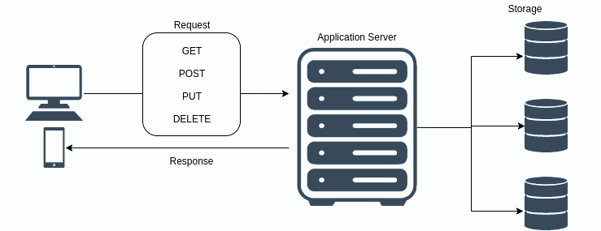
What is an Enterprise Application?
An Enterprise Application is a large-scale software system designed to operate in a business or corporate environment.
In Simple Words:
- An Enterprise Application is a big, business-focused software that helps organizations manage their daily operations in a digital and efficient way.
- If a web application or any type of application is designed to solve business problems, support large-scale usage, and operate securely and reliably — it is considered an enterprise application. Example: IRCTC

Client-Server Architecture (Big Picture for Web Applications)
Client-Server Architecture is a design pattern where the system is divided into two main parts:
- Client → The part that requests services (usually the browser or mobile app)
- Server → The part that provides services (processes the request, handles business logic, talks to database)

Real-World Analogy:
Think of a restaurant:
- Client = The customer (who places an order)
- Server = The kitchen (prepares the food)
- Waiter/API = Takes order to kitchen, brings back response

Technology Mapping: FE | BE | BE-DB
Technology / Module | Used For | Category
- HTML, CSS, JavaScript | - Creating structure, design, and basic interactivity | - 🟢 FE
- Bootstrap | - Styling and responsive design | - 🟢 FE
- React | - Building dynamic, component-based UIs | - 🟢 FE
- Core Java | - Core programming and logic building | - 🔵 BE
- Exception Handling, OOPs, Collections | - Logic, data handling, error management | - 🔵 BE
- File I/O, Networking, Java 8 Features | - Input/output, threads, streams, functional programming | - 🔵 BE
- JDBC (Java Database Connectivity) | - Connecting Java app with relational databases | - 🟡 BE-DB
- Servlets & JSP | - Dynamic server-side web pages & request handling | - 🔵 BE
- Hibernate | - ORM – Mapping Java objects to database tables | - 🟡 BE-DB
- Spring Core | - Dependency Injection, Inversion of Control | - 🔵 BE
- Spring JDBC | - Easier database access using Spring framework | - 🟡 BE-DB
- Spring MVC | - Web layer – handling HTTP requests/responses | - 🔵 BE
- Spring Boot | - Rapid backend and microservice app development | - 🔵 BE
- Spring REST API | - Creating RESTful APIs (used by frontend) | - 🔵 BE
- Spring Security | - Authentication, Authorization, JWT, OAuth | - 🔵 BE
- Microservices | - Breaking app into loosely coupled services | - 🔵 BE
- Spring AI | - AI features integration within Java backend | - 🔵 BE
- SQL, MySQL, Oracle | - Writing queries, managing relational data | - 🟡 BE-DB

Java Full Stack Development – Summary
- Java Full Stack means building both Frontend (UI) and Backend (logic + database) of a web application using Java technologies.

- Frontend (Client-side):
- HTML, CSS, JS, Bootstrap, React – used to design and build the user interface.

- Backend (Server-side):
- Core Java, Servlets, JSP, Spring, Spring Boot, Spring Security – used to handle logic, security, APIs.

- Backend + Database:
- JDBC, Hibernate, Spring JDBC, SQL, MySQL, Oracle – used to connect and manage data in databases.

- Web App vs Website:
- Web app is interactive (login, dashboard); website is mostly static (info only).

- Enterprise App:
- A large-scale software like IRCTC that solves business problems.

- Client-Server Architecture:
- Client sends request → Server processes → DB gives data → Response goes back.

